Unit 11 - Data Activity 9
Aim
A simple linear regression analysis was performed to determine whether systolic blood pressure (SBP) could be used to predict diastolic blood pressure (DBP). Systolic blood pressure was used as the predictor variable and diastolic blood pressure as the outcome variable.
R analysis: The analysis was performed in R
Figure 1. R output from the simple linear regression analysis predicting diastolic blood pressure from systolic blood pressure.

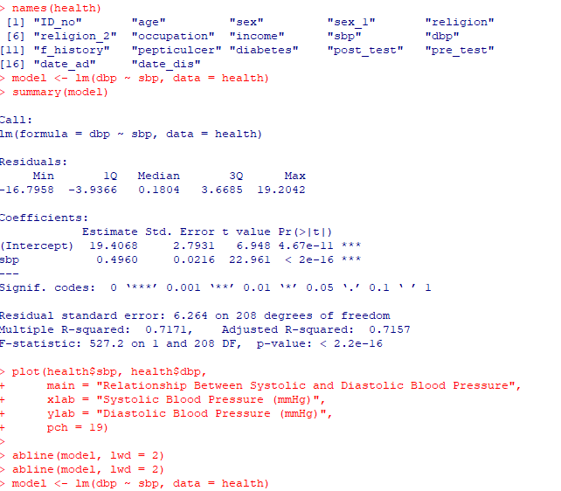

Regression equation
The regression analysis produced an intercept of 19.4068 and a regression coefficient of 0.4960 for systolic blood pressure. The estimated regression equation was therefore:
Predicted DBP = 19.4068 + 0.4960(SBP)
The coefficient of 0.4960 indicates that for every 1 mmHg increase in systolic blood pressure, diastolic blood pressure is predicted to increase by approximately 0.496 mmHg on average.
Scatterplot and regression line: A scatterplot was produced to examine the relationship between systolic and diastolic blood pressure, with the fitted regression line added.
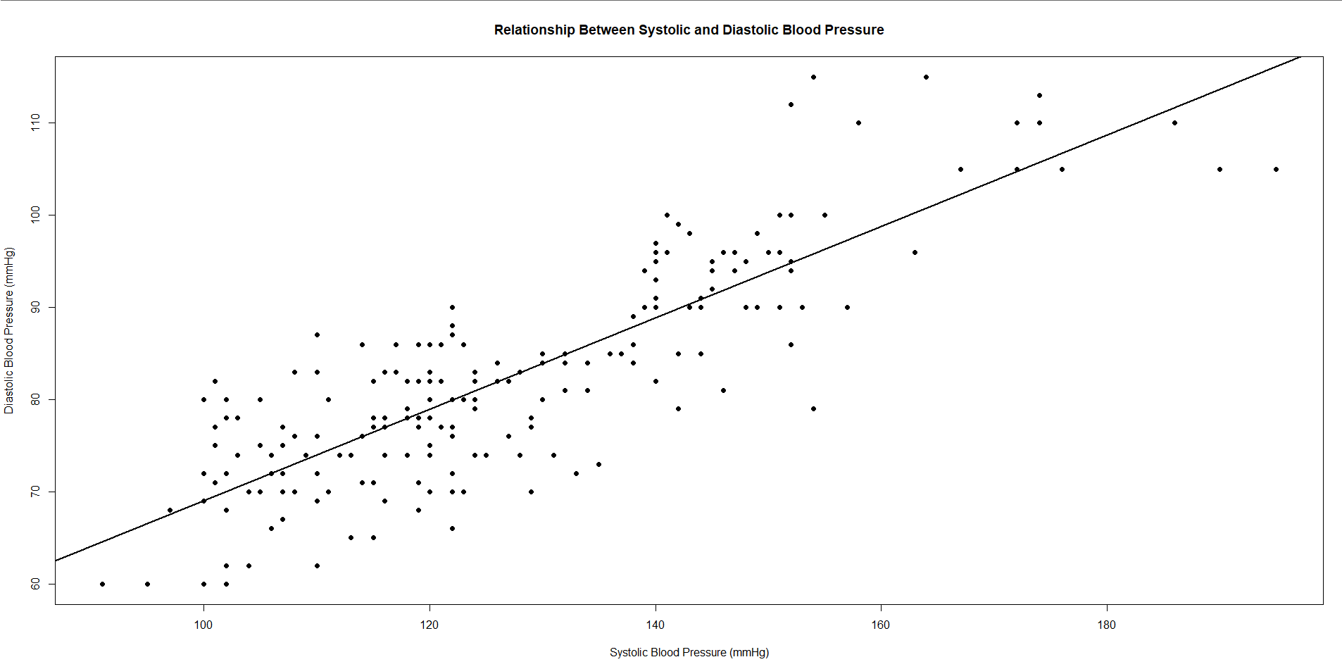

Figure 1. Scatterplot showing the relationship between systolic and diastolic blood pressure with the fitted linear regression line.
The scatterplot demonstrates a positive linear relationship, with diastolic blood pressure generally increasing as systolic blood pressure increases. This is consistent with the positive regression coefficient obtained from the model.
Interpretation at the 5% significance level
The overall regression model was statistically significant, F(1, 208) = 527.2, p < 0.001. The regression coefficient for systolic blood pressure was also statistically significant (b = 0.4960, t = 22.961, p < 0.001).
At the 5% significance level (α = 0.05), the null hypothesis is that the population regression slope is zero, meaning that systolic blood pressure does not have a statistically significant linear relationship with diastolic blood pressure. As the p-value was less than 0.05, the null hypothesis was rejected. There is therefore evidence of a statistically significant positive linear relationship between systolic and diastolic blood pressure.
The model had an R² of 0.7171, indicating that approximately 71.7% of the variation in diastolic blood pressure was explained by systolic blood pressure in this sample. The remaining variation was not explained by systolic blood pressure in this simple regression model.
Conclusion
The analysis found that systolic blood pressure was a statistically significant positive predictor of diastolic blood pressure. As systolic blood pressure increased, predicted diastolic blood pressure also increased. The regression model explained approximately 71.7% of the observed variation in diastolic blood pressure.

